Mechanical Overview

Year: 2023 Semester: Spring Team: 3 Project: “Rigged” Card Shuffler

Creation Date: Feb 8, 2023 Last Modified: Feb 11, 2023

Author: Brian Lee Email: lee3174@purdue.edu

Assignment Evaluation:

| **Item** | **Score (0-5)** | **Weight** | **Points** | **Notes** |
| --- | --- | --- | --- | --- |
| **Assignment-Specific Items** | | | | |
| **Commercial Packaging Analysis 1** |  | x2 |  |  |
| **Commercial Packaging Analysis 2** |  | x2 |  |  |
| **CAD Model Illustrations** |  | x4 |  |  |
| **Project Packaging Specifications** |  | x2 |  |  |
| **PCB Footprint Layout** |  | x2 |  |  |
| **Writing-Specific Items** | | | | |
| **Spelling and Grammar** |  | x2 |  |  |
| **Formatting and Citations** |  | x1 |  |  |
| **Figures and Graphs** |  | x2 |  |  |
| **Technical Writing Style** |  | x3 |  |  |
| **Total Score** |  | | |  |

5: Excellent 4: Good 3: Acceptable 2: Poor 1: Very Poor 0: Not attempted

Comments:

1. Commercial Product Packaging
   1. Product #1

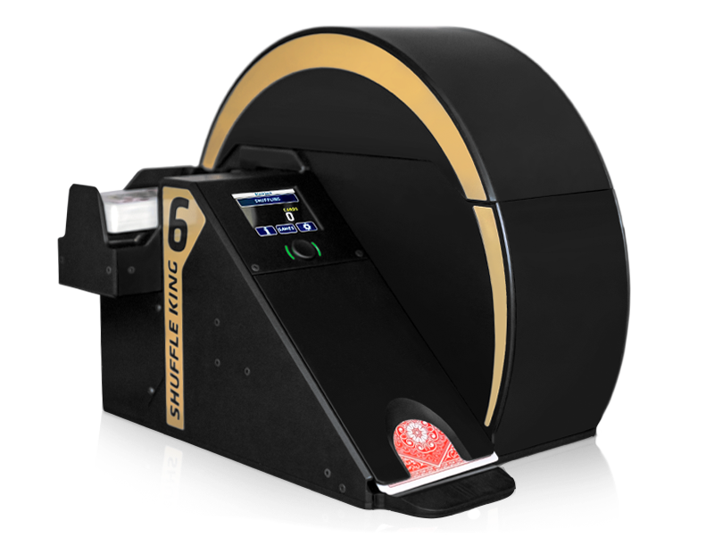

**Fig 1.** Packaging for Product #1, Shuffle King 6

A commercial product similar to the “Rigged” Card Shuffler is the Casino Shuffler Shuffle King 6 [1]. This device also accepts cards, inserts them into a wheel, and outputs cards. While it does not perform tasks such as card recognition and controlled-order card output, its mechanical actions are quite similar, and thus is a comparable device to analyze with regard to packaging.

Based on its site and published manual, the Shuffle King 6 appears to have plastic packaging. This is definitely a positive design decision as it allows the device to have a relatively low total weight despite its somewhat cumbersome size and inclusion of relatively heavy internal components such as motors. It has a broad base, which allows for more stability when laid on a flat stable surface during operation.

The card insertion area on the Shuffle King 6 is designed as partially free hanging. This is certainly a design negative as, while it may leave room for a motor to draw cards off the bottom of the pile, it does not leave much room for other components under the card insertion area. The card dispensing area on the Shuffle King 6 is also suboptimal as it only leaves room for one output card, requiring the user to remove the dispensed card before the next card can be sent out.

Similar to the Shuffle King 6, it is planned that most packaging for the “Rigged” Card Shuffler will be plastic or other lightweight material to mirror the Shuffle King’s reasonable total package weight. The broad base is another feature that is planned to be co-opted to ensure that motor operation does not cause excessive device shaking. However, the card insertion and dispensing areas will not be mimicked as they do not allow for proper room for mounting the camera and proper clearance for multi-card dispensing, respectively.

* 1. Product #2

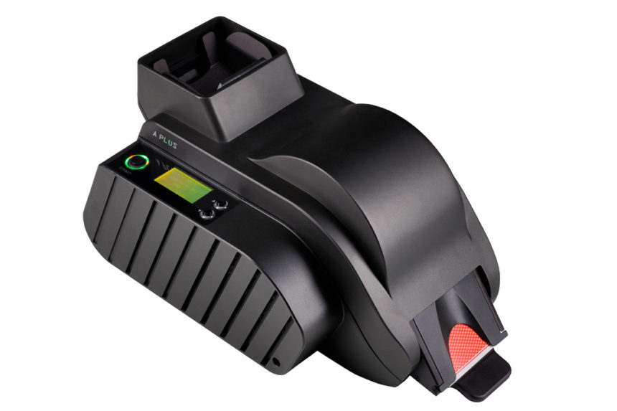

**Fig 2.** Packaging for Product #2, the A Plus Shuffler

Another similar commercial product is the TCSJOHNHUXLEY A Plus Shuffler. The A Plus performs a similar function with the “Rigged” Card Shuffler in that it accepts cards from a top-loading area, allows the user to input options such as game choice and player number via an on-board screen and buttons, and dispenses cards.

The A Plus boasts a lightweight package, most likely of a plastic material, which is excellent. It also has an “in-line” design, wherein the insertion, shuffling mechanism, and dispensing are collinear as opposed to one or more mechanisms being offset from the others. It also features a very simplistic user interface, which seems to be easy to use and, because it uses buttons instead of a touchscreen, is relatively durable.

The device, however, also has some negative aspects. Most importantly, the dispensing mechanism only allows for one card to be dispensed at a time. This is not an optimal design for our use case of rigging an entire deck at once.

In conclusion, design aspects such as the top load, the lightweight material, and the simplistic user interface can be adapted for the “Rigged” Card Shuffler, while aspects like the single-card dispenser design would be better left behind.

2.0 Project Packaging Description

As seen in Appendix 1, the packaging will be mostly in a box shape, with a cutout for the shuffle wheel to extend out. The device will have a broad and flat base such that it can be placed on a level surface and operated in a stable fashion. It will have a slot on the top for inserting cards and a hole at the bottom for accessing dispensed cards. Lastly, on the front of the device, there will be an area for the interface PCB, consisting of the screen and buttons, to be mounted.

The major philosophy of this design is to not expose as little of the interior of the device to the user as possible. Because there will be moving parts, it is imperative that no stray objects, including the user’s hands, interfere with operation of the device lest the user is injured or the device is damaged.

3.0 Sources Cited

[1] Casino Shuffler. *Shuffle King 6* [Online]. Available:

<https://www.casinoshuffler.com/subdom/shuffleking6/>

[2] TCSJOHNHUXLEY. *A Plus Shuffler* [Online]. Available:

<https://www.tcsjohnhuxley.com/products/shuffler> **Appendix 1: CAD Model Illustrations**

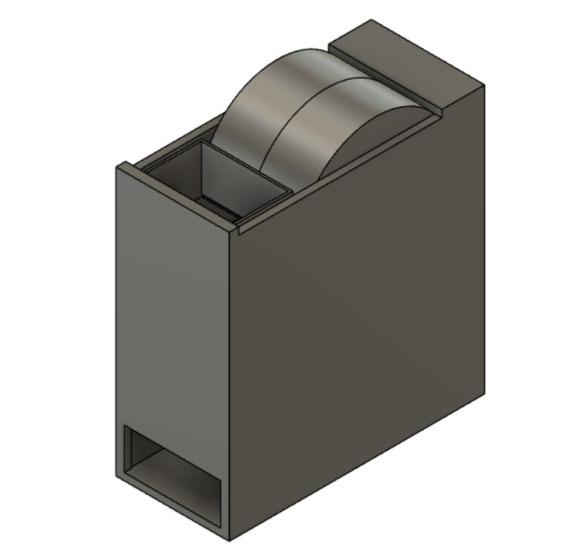

Major Dimensions: Height = 11.1 inches, Length = 10.6 inches, Width = 4.6 inches

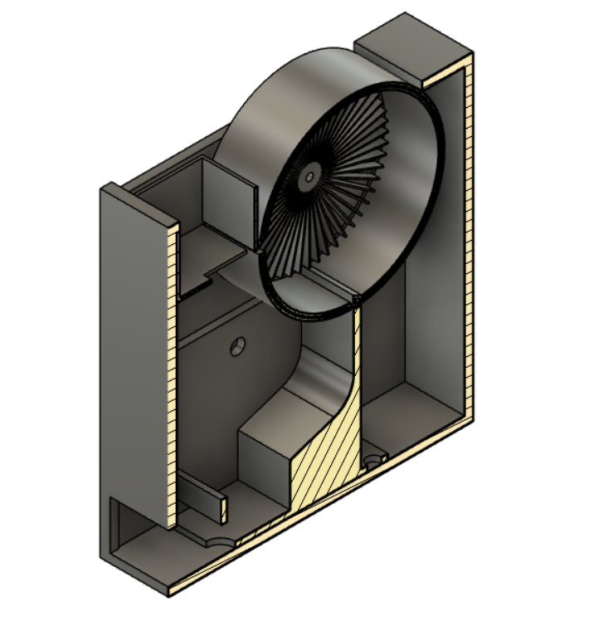

(Camera is mounted below insertion area)

**Appendix 1 (Updated) (additional figures added 1 March 2023)**

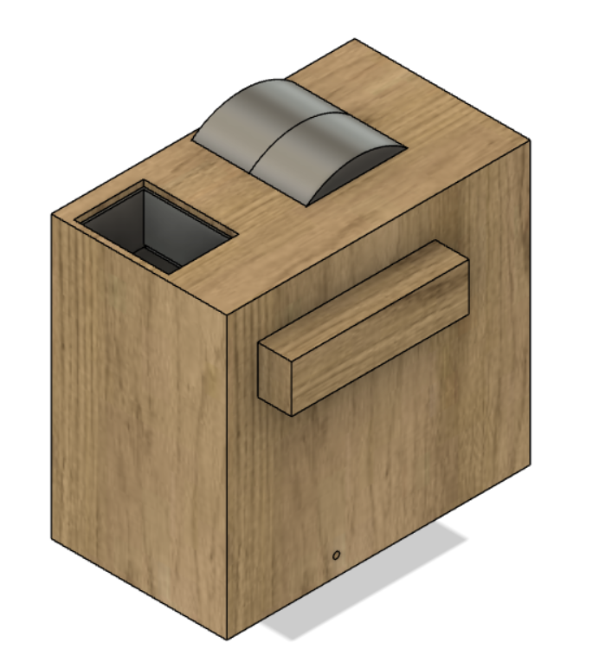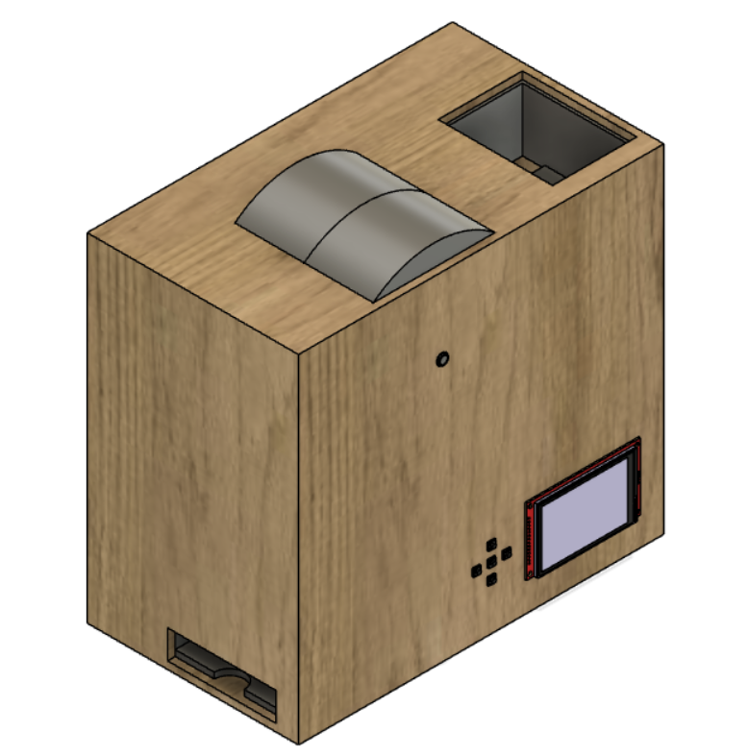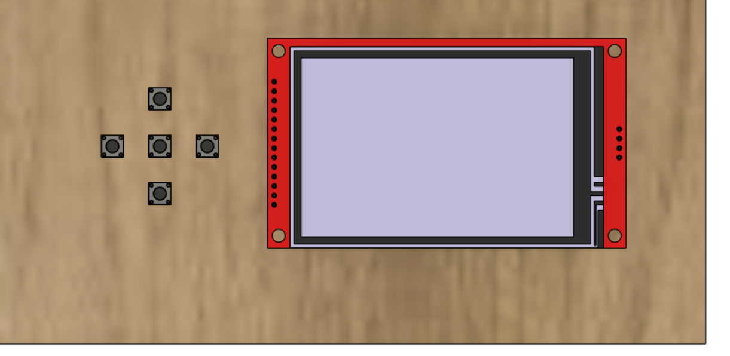

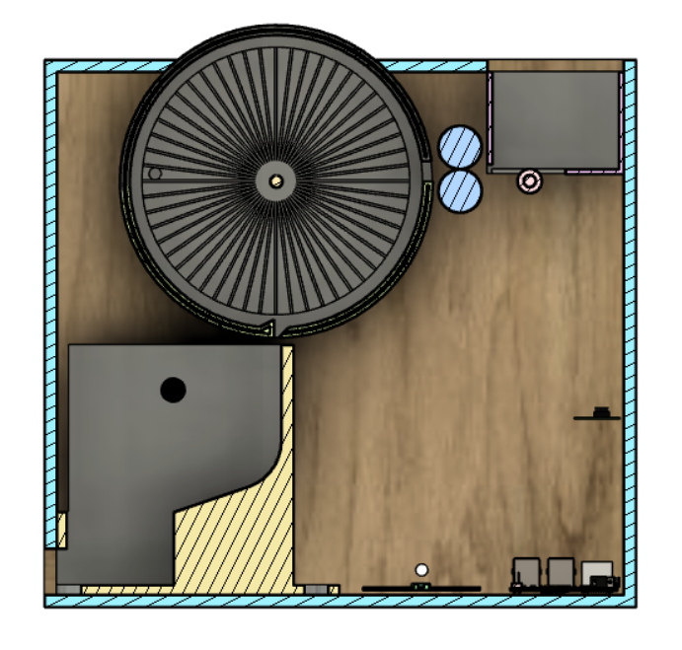

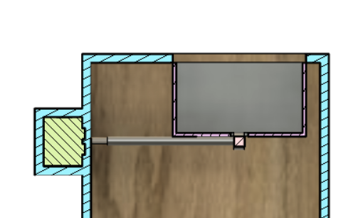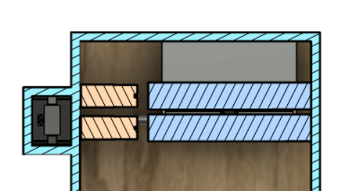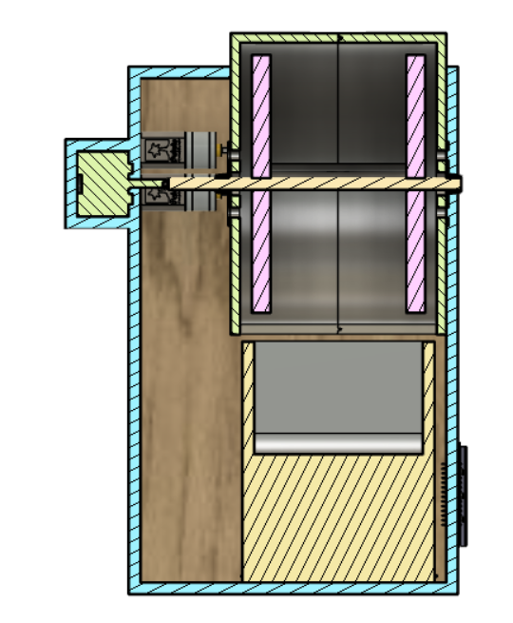

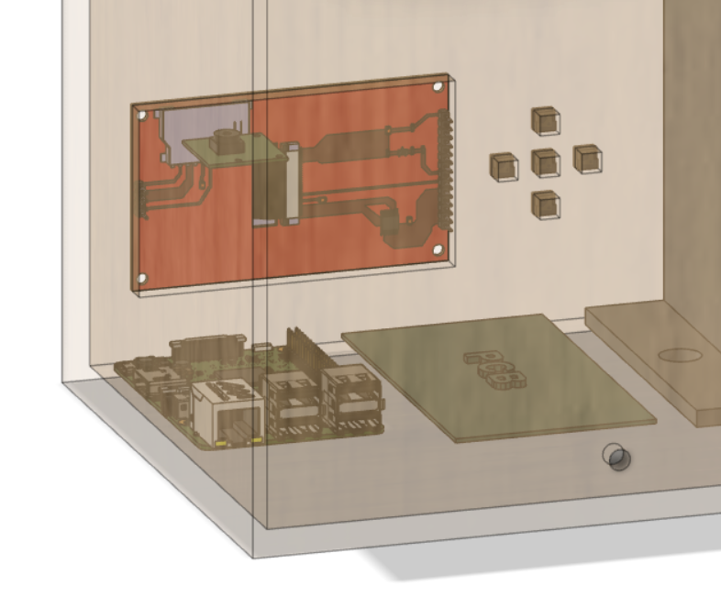

Appendix 2: Project Packaging Specifications

| **Material** | **Tools Required** | **Quantity** | **Cost** |
| --- | --- | --- | --- |
| 2.85mm PLA | 3D Printer | 186.3 in^3 | $30 |
| Bearings | None | 2 | $5 |
| Bolts | Hex key | 20 | $10 |
| Nuts |  | 20 | $10 |
| Screws | Screwdriver | 4 | $2 |

Appendix 3: PCB Footprint Layout

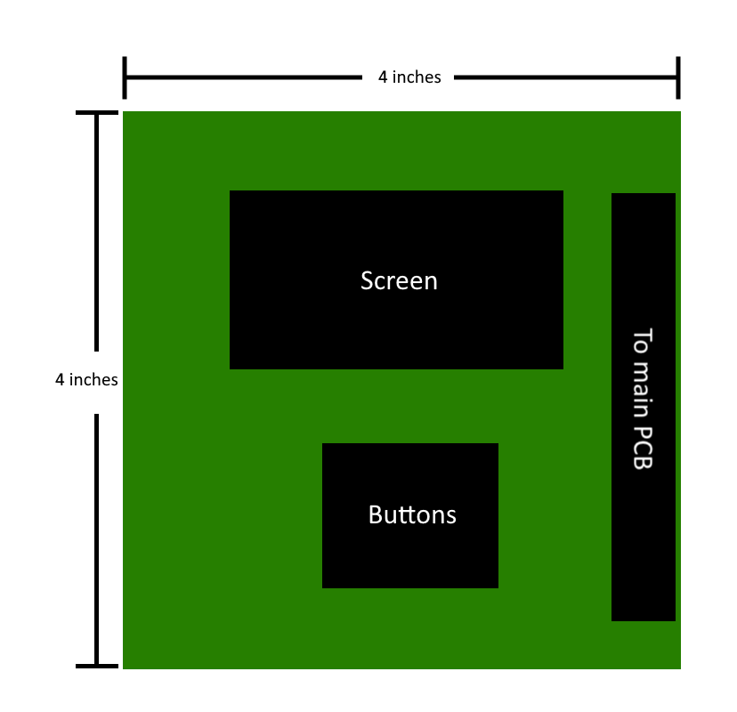

**User interface PCB**

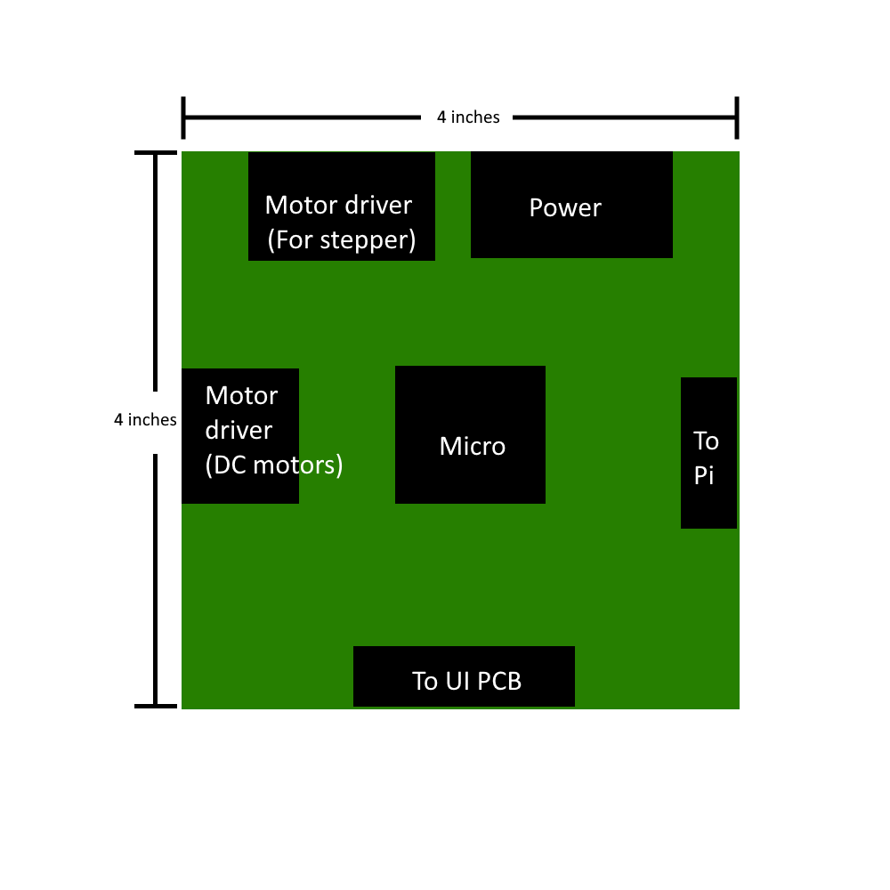

Main PCB